Seattle Weather Project Results

Seattle is one of the rainiest cities in the world and is known for its tendency to be gloomy and cloudy, but is it really that different from one of the rainiest islands in the world? My parents moved from the Pacific Northwest to the big island of Hawaii a few years ago, and I found myself here in Seattle studying data. Through this task of analyzing the precipitation differences, I now know that the city of Seattle receives more than twice as much rainfall as the town my parents live in. Kailua-Kona is a beautiful mountain town nestled in the mountains of the three volcanos that comprise the island, but it is not nearly as rainy as the eastern side of the mountains where Hilo receives about 130 inches of rain annually.

The data used to conduct this analysis was ordered and retrieved from the National Oceanic and Atmospheric Administration (NOAA) on September 30th 2025. The data was received in two comma-separated value (CSV) files and contains standard measurements used to determine weather conditions and patterns. I used descriptive analysis to allow a broad view of the dataset, and some regression techniques to normalize the data such as averaging NULL values.

In the 5 years analyzed for this project, from 2018 to 2022, Seattle received an average of 40 inches of rain a year and Kailua-Kona received just about 10.

As shown in the location names above, the best quality data I could retrieve was from the regional airports near both cities. Based on the sum totals alone, it's easy to assume that the inclement weather in Seattle is significantly more frequent than in Kona. However, there is much more to inclement weather than rainfall alone. My intent as I continued my analysis was to determine how many more days of rain Seattle experiences, and how much the snow in Seattle accounts for the extra precipitation.

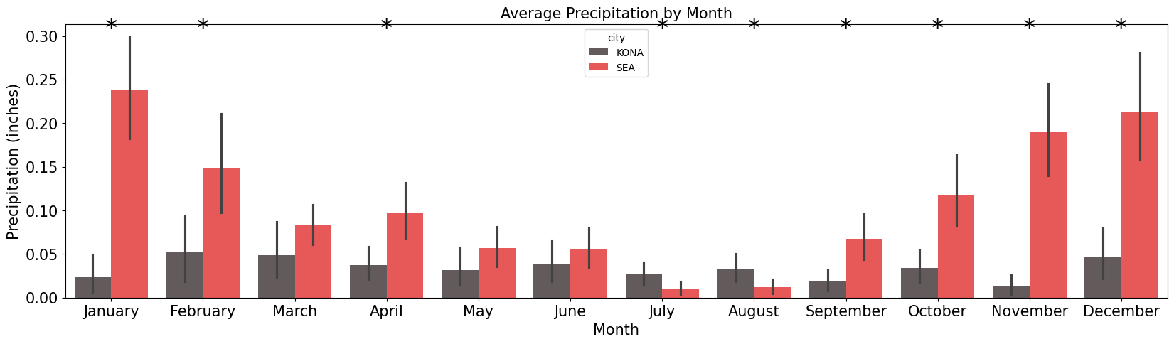

The first graph I produced showed clearly that a large percentage of the difference in precipitation could be accounted for in the winter months in Seattle. In fact, the only months where Kona sees more rain on average is July and August. Kona sees relatively consistent amounts of precipitation all year, while Seattle varies widely throughout the seasons. Subsequently, I wanted to know how this observation would change if the snowfall in Seattle wasn't considered in the comparison of precipitation.

To create this graph, I added a measure for the total precipitation recorded minus the total snowfall recorded for each day. We see major changes in the winter months, as could be expected, but February specifically dives into a negative value. Interestingly, March changed to a significant difference in precipitation when snowfall was removed from the comparison, meaning the snow in Seattle causes the precipitation to be more similar between the two cities. Seattle only records snowfall between the months of November and March, so I am able to conclude that there is a significant difference in the rainfall between Kona and Seattle mostly due to actual rain rather than snowfall.

The summer months of June and July are relatively similar for Kona, Hawaii and Seattle, Washington but the seasons experienced in the Pacific Northwest make the two locations significantly different. Spring and late fall see large upticks in precipitation for the city of Seattle that the island nation of Hawaii doesn't really follow. The Pacific ocean has its own weather patterns and rainy seasons, but those tend to ebb and flow with the moon cycle rather than the sun. In conclusion, I believe the snow in Seattle accounts for the majority of the differences in precipitation but that sunny Hawaii is full of surprises; one side of the island rains possibly three times as much as Seattle, the other side half as much.